How to setup :

+ extract HeroOnline.rar to HeroOnline directory.

+ Download models : link <http://www.mediafire.com/download/dgkeueedy9y83m9/Models.rar>

(contact to support : [khoavnm@blueskysoft.vn](mailto:khoavnm@blueskysoft.vn) , skype : xmen9999vn)

Copy models.rar to HeroOnline\Assets\StaticResources , right click file and select extract here.

View directory tree of Models :

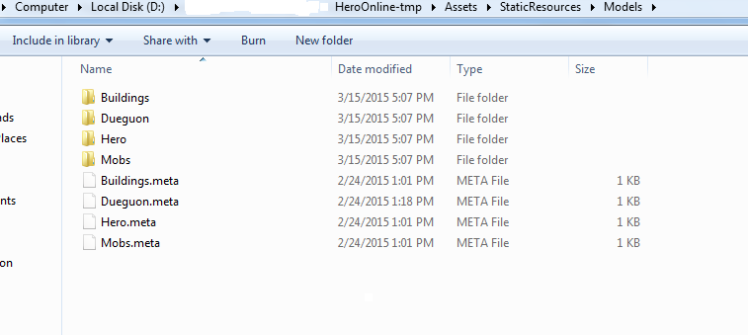

Require Visual studio 2012 .

1-Setup SQL Server 2012 : Attach db GameDB_01.mdf , MainDB.mdf

Open sql server management-> click Database-> Att ach->Add->select PhotonSDK\SQLData\ GameDB_01.mdf->Ok->ok

Open sql server management-> click Database-> Att ach->Add->select PhotonSDK\SQLData\ MainDB .mdf->Ok->ok

+ Config server master ip address is your server ip in database: open database chọn maindb ->table dbo.World->edit

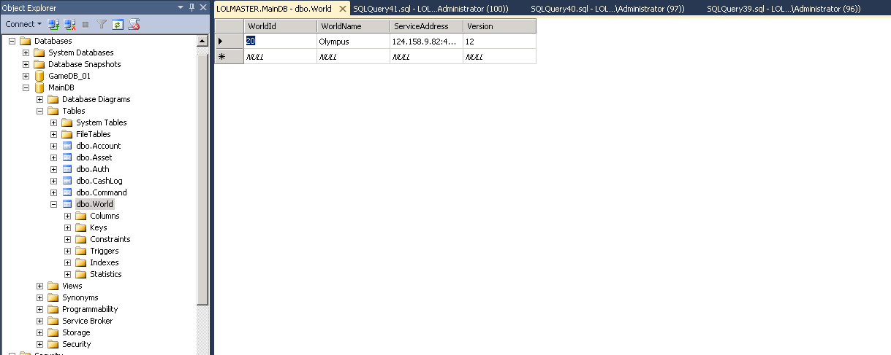

+ config sql connect string : open DEngine.HeroServer.dll.config file with notepad in PhotonSDK\deploy\HeroOnline directory: hostname of database server

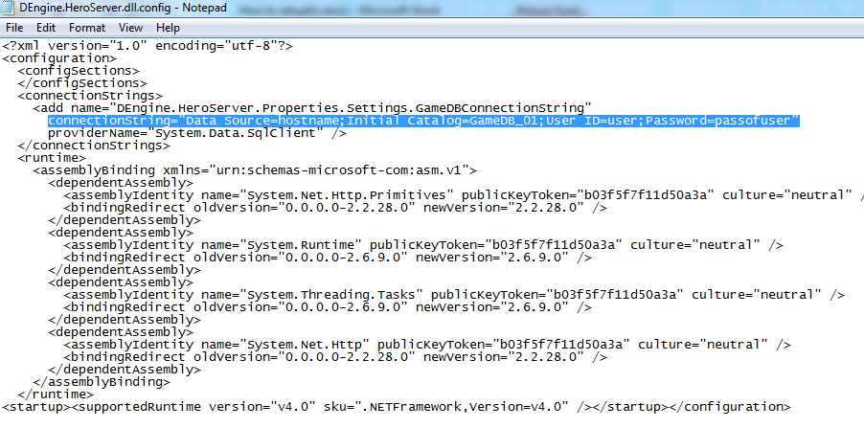

2-Setup to run photon server :

2.1 setup and config IIS (**Internet Information Server** )in server to run webservice in service.leagueoflords.vn directory .

+Copy service.leagueoflords.vn directory into wwwroot directory in server computer.

Create webservice in iis :

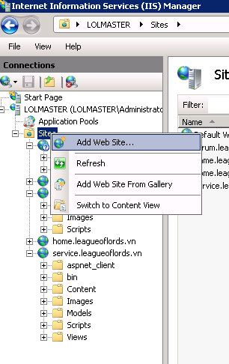

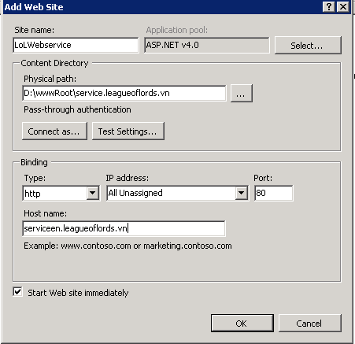

Change Hostname : servicemen.leagueoflords.vn-> your domain .

+Run test websirve : input in internet explore : your domain/ game/getworlds -> enter

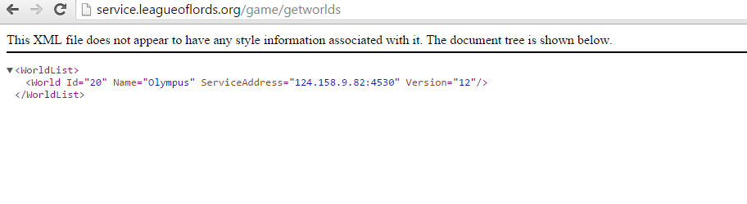

2.2 Copy photonSDk directory to server computer .

+config master server ip in PhotonSDK\deploy\HeroOnline\Config\serverconfig.xml

<?xml version="1.0" encoding="utf-8" ?>

<ServerConfig>

<MasterIP>127.0.0.1</MasterIP> (master server ip)

<MasterPort>4520</MasterPort>

<ZoneMaxCCU>500</ZoneMaxCCU>

<WorldId>20</WorldId>

<ServiceUrl>http://service.leagueoflords.vn</ServiceUrl> (your webservice link)

</ServerConfig>

+Open UIServerMenuManager.cs file in client :

line lolServiceUrl = "http://service.leagueoflords.org/Game/GetWorlds";// change to http://yourwebservicelink/Game/GetWorlds

+ Run photon PhotonSDK\deploy\bin_Win32\photoncontrol.exe

+Click photon icon in task bar :

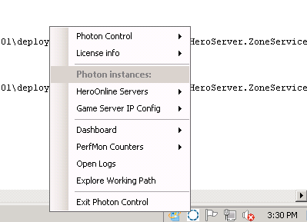

+click HeroOnline Servers -> Install service

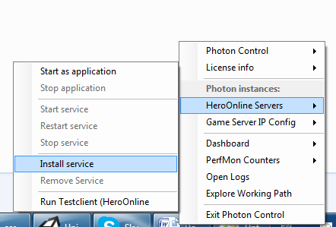

Then start service : (if error code 108 in log file, check connect string in DEngine.HeroServer.dll.config file)

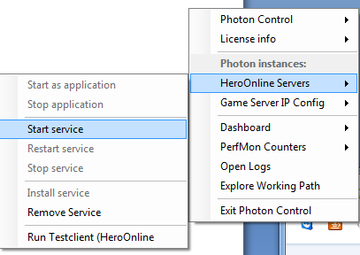

Support : blueskysoft.vn@gmail.com